Fire4s

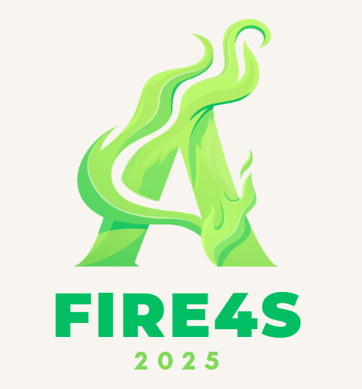

<https://landbot.online/v3/H-2960759-8Q6ZR8L6YYD88MKK/index.html>

**Project Name:** AI Educational ChatBot Fundamentals

**Conducted by:**  
Oko Mwezo

Neo Mokoana

Seeipati Sithole

Thokozani Maleka

**Planning Phase**

We implemented a chatbot that applies AI fundamentals to provide assistance and information in a more conversational way, which helps reduce workloads and improve engagement and educational topics. The chatbot also aims to enhance the user experience, it is regarded as a personal virtual tutor.

Within the Technical specifications, the chatbot is designed with more than one option for relevant information based on your chosen topic.

**Implementation Phase**:

We used LandBot software to design a dialog flow between the Bot and the end-user. The Chatbot was made to ensure that once access to the necessary FAQs(Frequently Asked Questions) and relevant information about AI, we developed a questionnaire in a more conversational way. We then tested the development of the chatbot by identifying/detecting end-user conversational flow.

**Conclusion:**

Using LandBot, the implementation phase effectively brought the AI Educational ChatBot to life, allowing for an engaging and lively conversation flow. The chatbot now efficiently assists users in comprehending AI ideas by incorporating topic-based knowledge and frequently asked questions into a conversational manner, improving learning and engagement.

**References:**

*AI Chatbot Generator for conversational experiences* (no date) *Landbot.io*. Available at: https://landbot.io/ (Accessed: May 27, 2025).